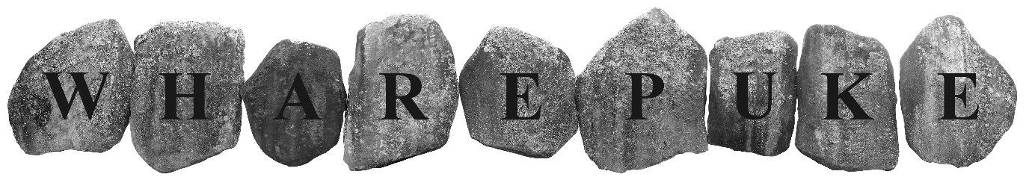
SCULPTURE TRAIL
www.art-park.co.nz
DALTON TRUST KERIKERI ARTIST IN RESIDENCE 2026
proposal/application form:
By email to:
info@art-at-wharepuke.co.nz
Wharepuke
190 Kerikeri Road
Kerikeri 0230

DEADLINE FOR APPLICATIONS IS 5PM FRIDAY MAY 17th, 2026
Selected artist will be notified by May 31st

THE WHAREPUKE/DALTON TRUST KERIKERI ARTIST IN RESIDENCE
Valued at NZ$6,400.00, the 2026 residency is open for proposals from NZ & International artists to create a work on site for the Wharepuke Sculpture Trail in Kerikeri, New Zealand.
Proposed works must be suitable for outdoor display and can be 3D/2D, sculpture, installation, sound, video etc.
Artist Receives:
- 4-week residency - between July 15th and September 30th, 2026 - artist and Wharepuke to negotiate exact dates
- Artist’s fee $4000.00 NZ
- Accommodation (valued at $2400.00) – self-contained one bed cottage in 5 acres of subtropical Garden of National Significance– partners/family welcome
- Studio space if required (25m²)
- Outdoor 6 x 3m covered work area
- Artist talk – public talk in the art gallery (optional)
- Opening Reception for the new work
- Work should be a permanent installation or purposefully ephemeral for the sculpture park
- Web sites – Wharepuke Sculpture Park, Art at Wharepuke & Artist Residency web page
- Selected artists may also propose to site other works for sale within the sculpture park and/or small works in the gallery.

NAME: Click or tap here to enter text.
ADDRESS: Click or tap here to enter text.
EMAIL: Click or tap here to enter text.
YOUR WEB SITE: Click or tap here to enter text.
PHONE: Click or tap here to enter text.
BANK ACCOUNT DETAILS FOR PAYMENT OF ARTIST’S FEE/SALES:Click or tap here to enter text.
NZ GST REGISTERED? YES ☐ NO ☐ GST NO. Click or tap here to enter text.

PROPOSAL – Outline of plan/project: Click or tap here to enter text.
PREFERRED DATES please indicate 4 weeks between July 15th & Sep 30th, 2026 Click or tap here to enter text.
5 – 10 IMAGES OF RECENT WORK Y ☐
ARTIST STATEMENT IN RELATION TO CURRENT BODIES OF WORK: Click or tap here to enter text.
DOES WORK HAVE ANY SPECIAL INSTALLATION OR ON-GOING MAINTENANCE REQUIREMENTS? (Artists may have to provide specialist equipment if necessary) Click or tap here to enter text.
HAVE YOU VISITED WHAREPUKE? Y ☐ N ☐
IF SO, DO YOU HAVE A PARTICULAR SITE IN MIND? Click or tap here to enter text.
We encourage artists to visit, if possible, prior to the residency and can, if available, offer accommodation for a short research visit.
(N.B. We will work in consultation with the artist, but final siting of works will be at the discretion of the curators/directors of Art at Wharepuke)
WHERE DID YOU HEAR ABOUT THIS OPPORTUNITY?Click or tap here to enter text.
WOULD YOU LIKE TO PROPOSE ADDITIONAL WORKS FOR SALE IN THE GALLERY? Y☐ N☐
WOULD YOU LIKE TO PROPOSE ADDITIONAL WORKS FOR SALE IN THE SCULPTURE PARK? Y☐ N☐

APPLICATION PROCESS:
Please Include:
- Application form ☐
- Detailed proposal – Word or Pages format ☐
- Short bio, CV ☐
- Artists Statement ☐
- 5 to 10 Jpeg Images of recent work. Please use Wetransfer etc. for large files if necessary. Please label Jpegs ‘YourName_Title’ e.g ‘MarySmith_TheKiss’ ☐

DEADLINE FOR APPLICATIONS IS 5PM SUNDAY MAY 17TH 2026
Contact/Questions:
Mark Graver/Tania Booth
info@art-at-wharepuke.co.nz

I agree to the terms and conditions as detailed in this proposal and on the Terms and Conditions PDF

Artist’s signature: ................................................................................. Date: .....................

